Area: 2089 Sq.ft.
Style: Contemporary

The Brief
The homeowners wanted a simple, functional family home built on a regular rectangular plot in Changanassery. Their core request was for an open and spacious layout with good connectivity between indoor and outdoor areas. Being based abroad, they also wanted a smooth and transparent construction experience that allowed them to stay fully involved remotely.
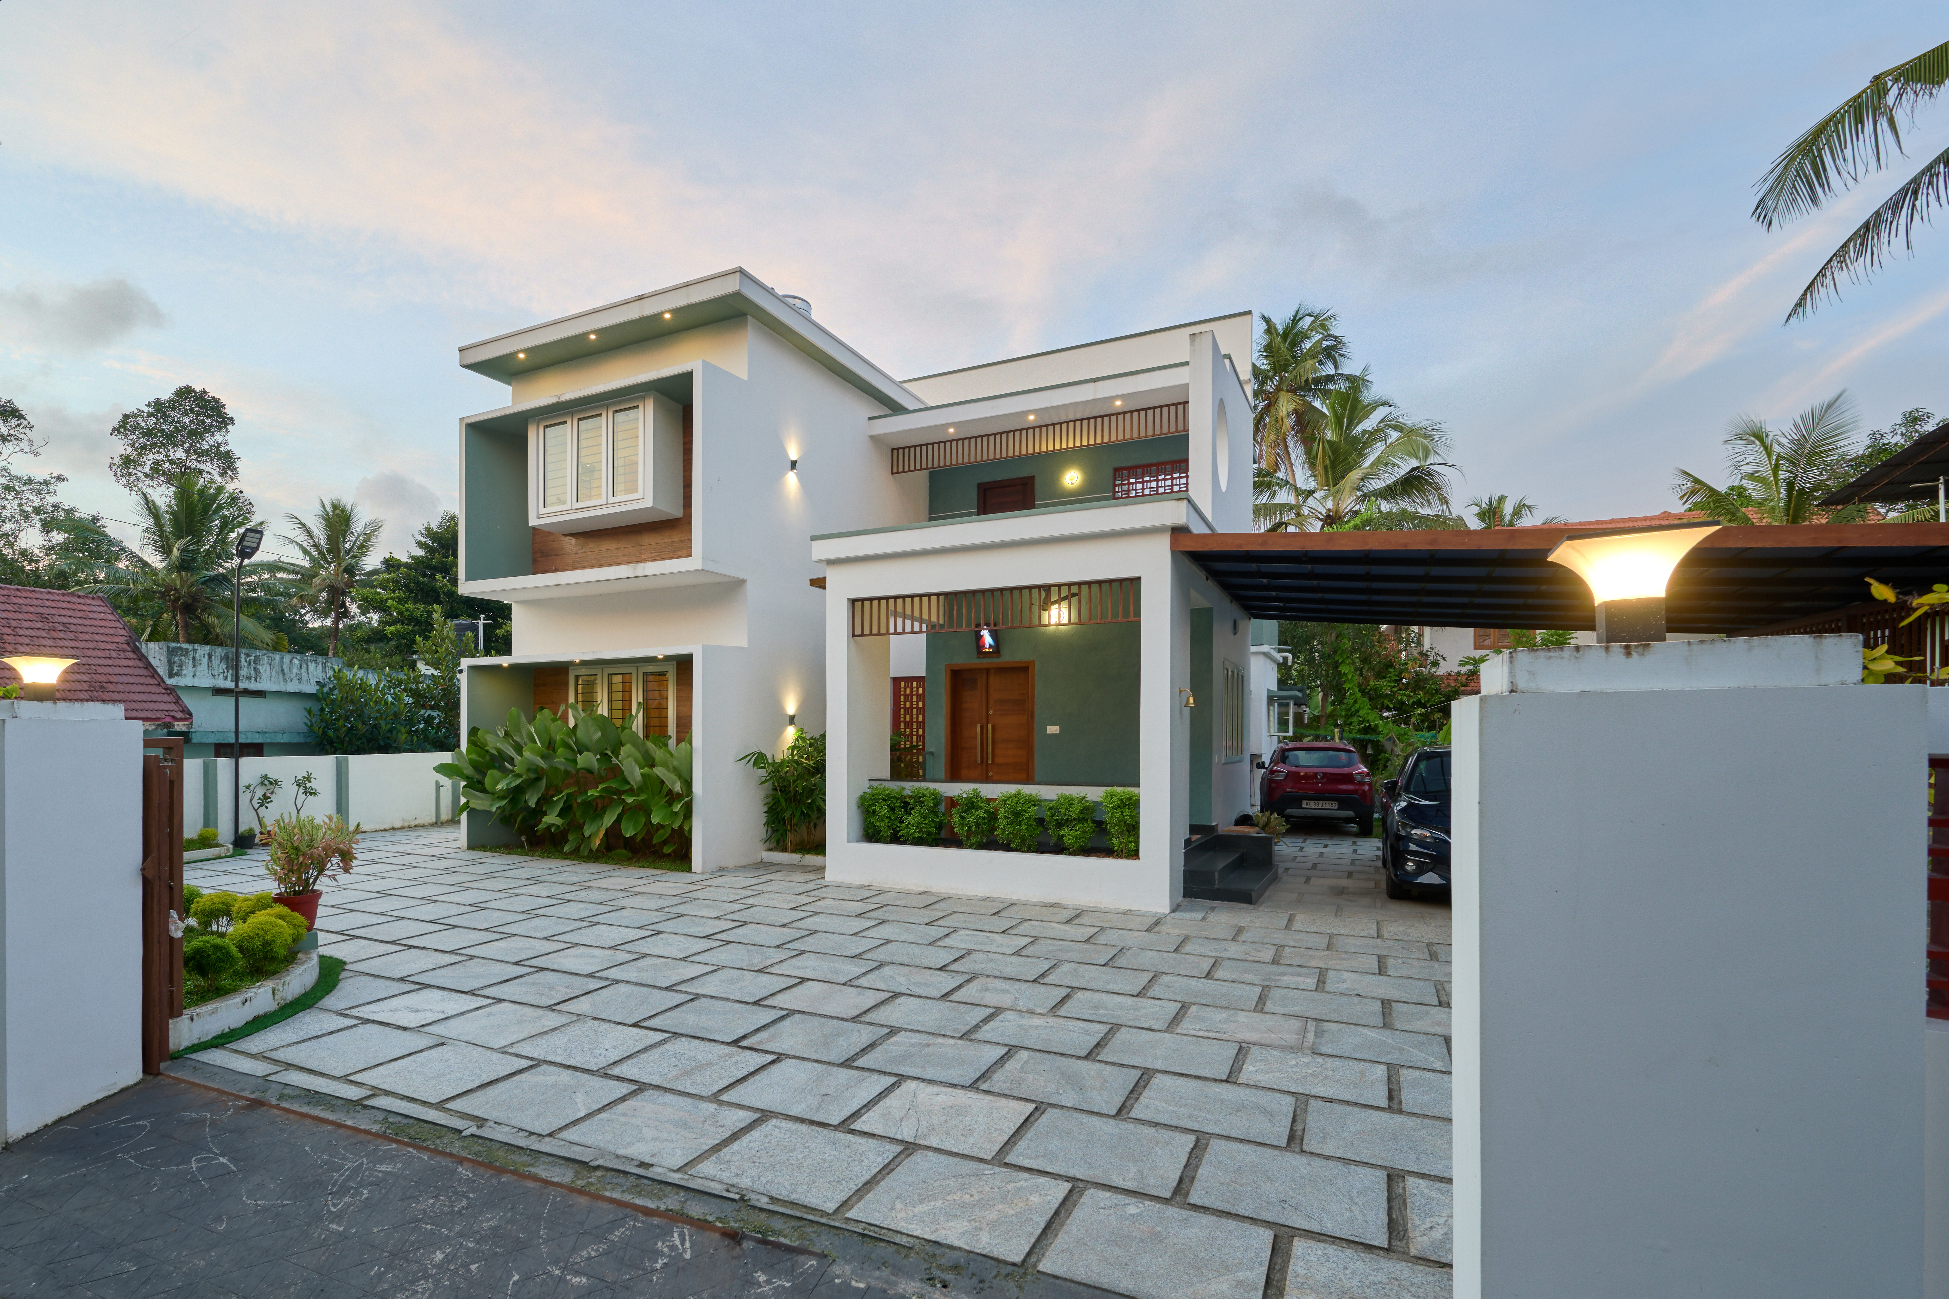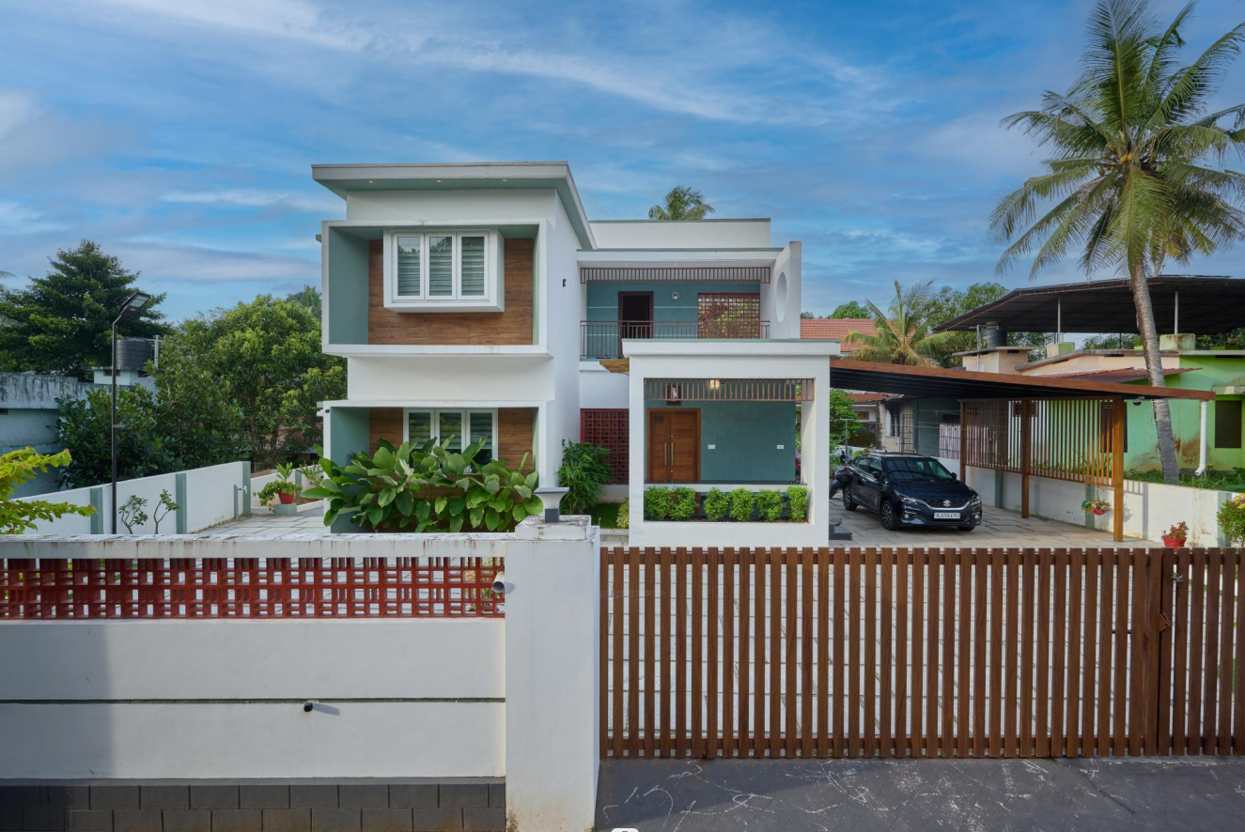

Design Concept
BuildNext’s design team envisioned a home that would feel airy and cohesive, blending modern minimalism with subtle warmth. The layout was planned as an open floor plan connecting the living, dining, and kitchen areas seamlessly. The introduction of large openings and sliding glass doors allowed natural light to flood in while visually linking the interiors with the outdoors.

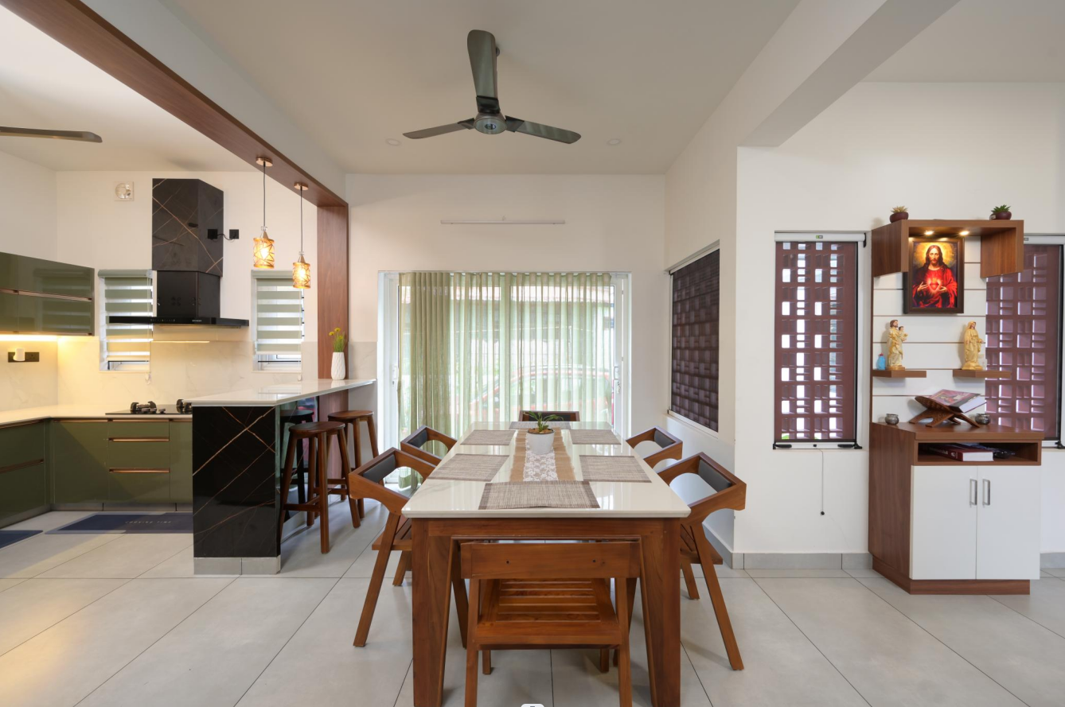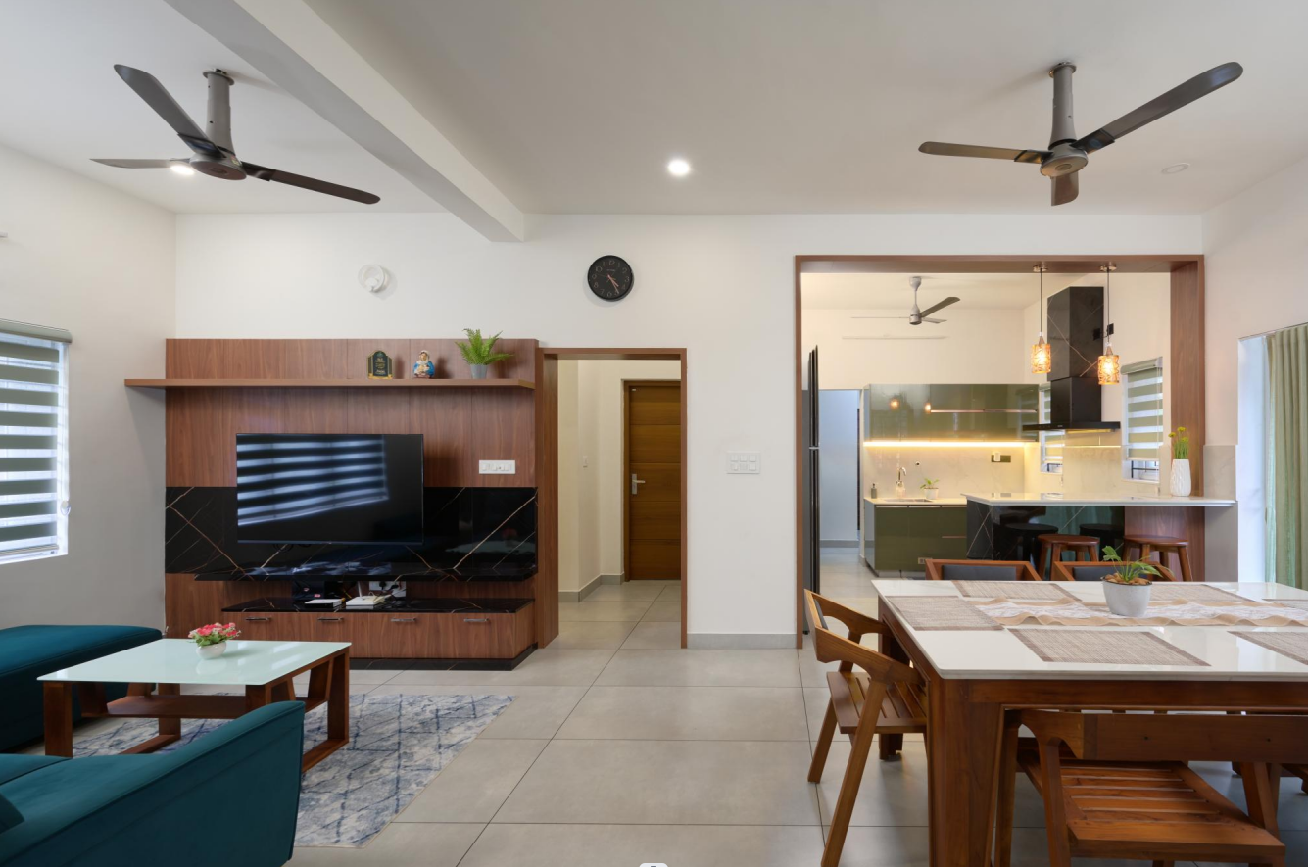

Planning Highlights
The spatial planning of this home was centered around openness, light, and connection. The ground floor brings together the living, dining, and kitchen areas in a single, flowing layout that encourages interaction and easy movement. A sleek open kitchen seamlessly merges with the dining space, while a separate working kitchen ensures practicality without compromising aesthetics. The dining area extends toward the outdoors through a large sliding glass door, creating a visual and physical link to the exterior. At the entrance, the prayer area is thoughtfully positioned to remain visible, offering a calm and spiritual focal point as one enters the home. All four bedrooms are designed with attached bathrooms and feature bay windows that bring in soft natural light. The kids’ bedroom, in particular, includes dedicated computer and study spaces, blending comfort with functionality. The home also includes two living areas, one designed to welcome guests and another cozy family space with a TV unit for everyday use.
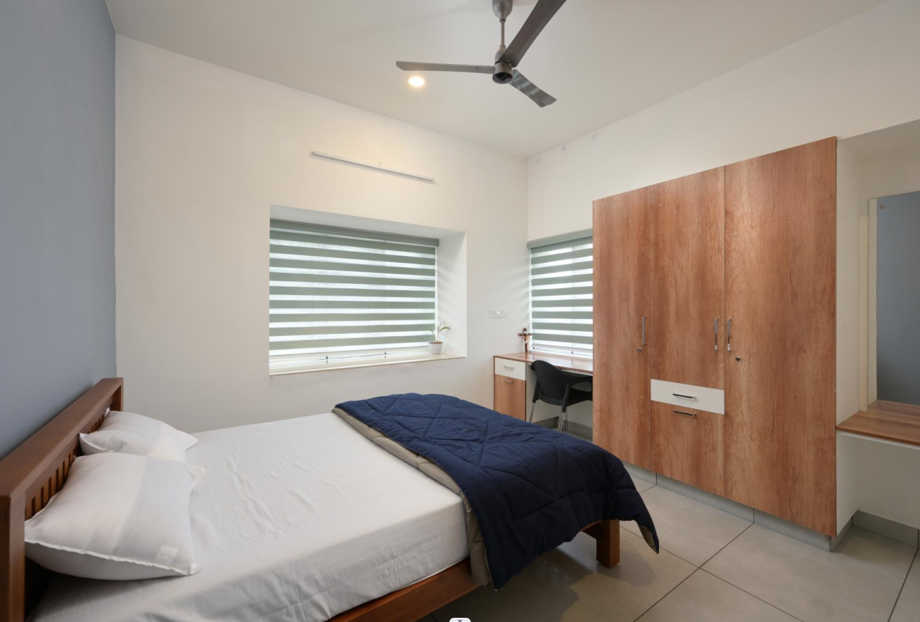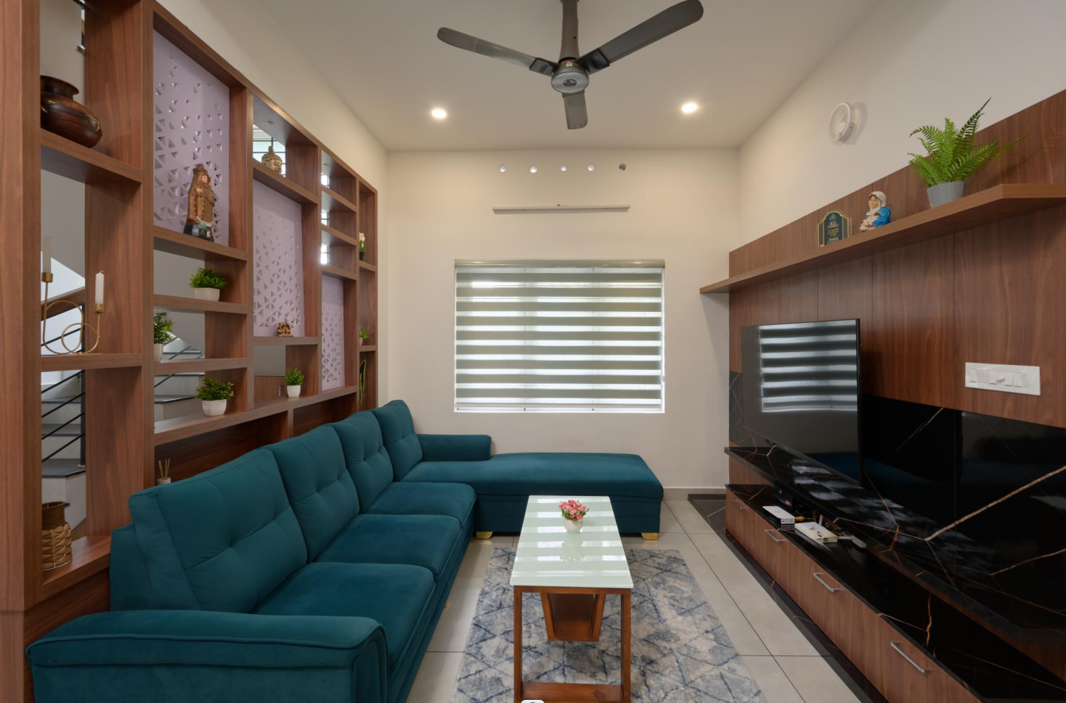
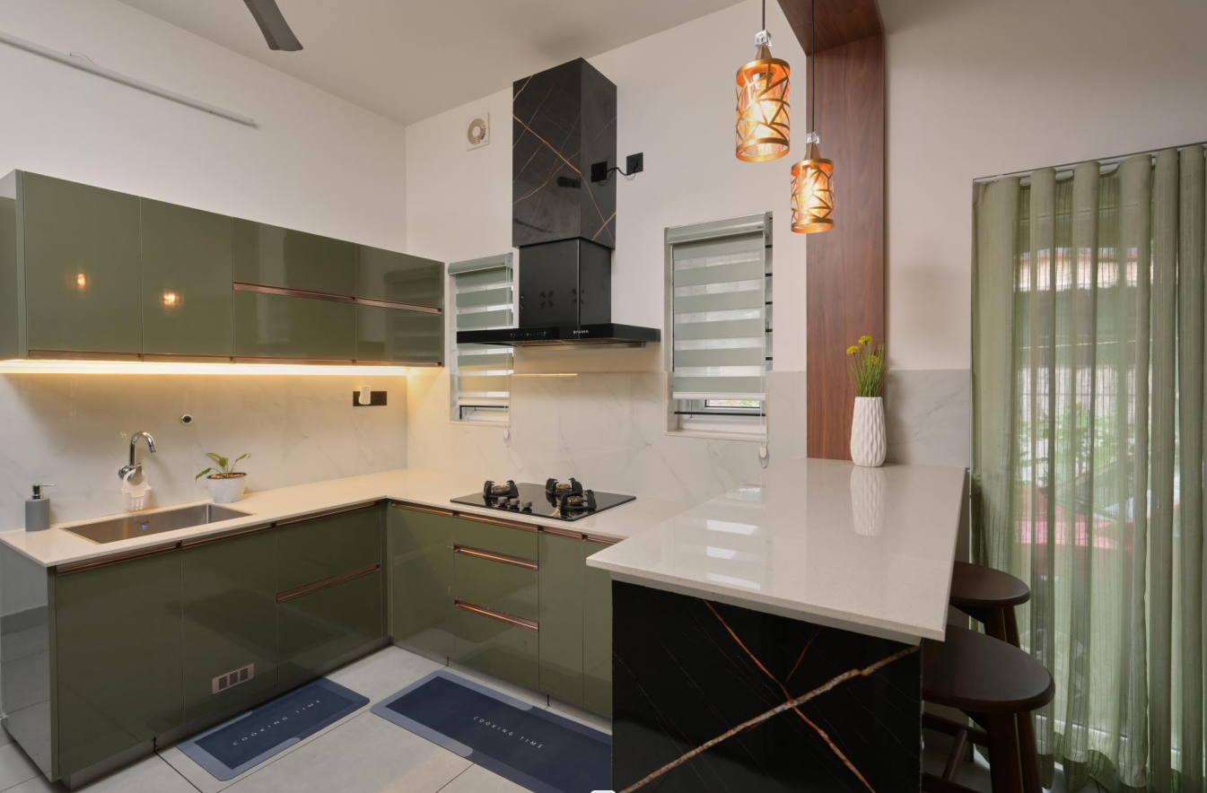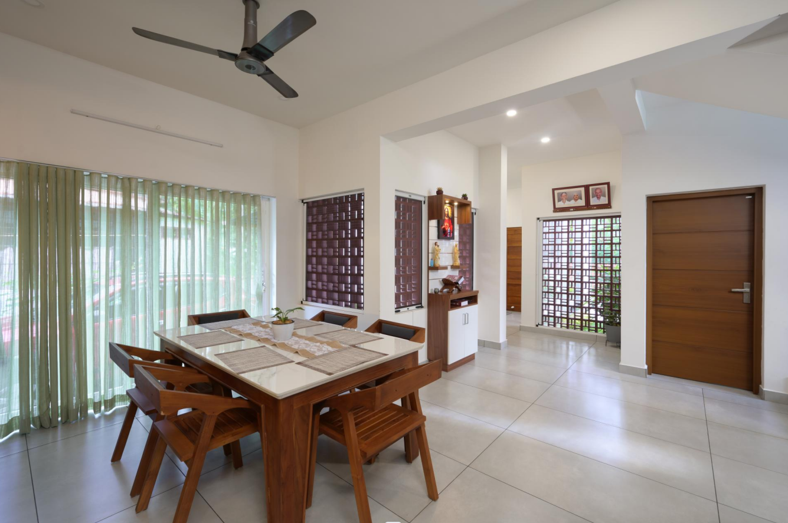

BuildNext Advantage
Since the client was living abroad, BuildNext’s Mobile App became their construction companion, enabling them to track site progress, review updates, and attend virtual meetings at their convenience. Every stage of the project, from material selection to finishing details, was coordinated seamlessly through the app, ensuring transparency and trust.

The Result
The final home stands as a clean-lined contemporary residence that radiates comfort and warmth. The balance between open spaces, functional zones, and natural light creates a refreshing environment perfect for modern family living.
