Style: Contemporary

The home is located in a peaceful residential area, ideal for a family seeking a modern yet calming living environment. The client, based away from the site, entrusted BuildNext with the complete design and execution process, relying on the BuildNext Mobile App to stay connected throughout every stage of construction.
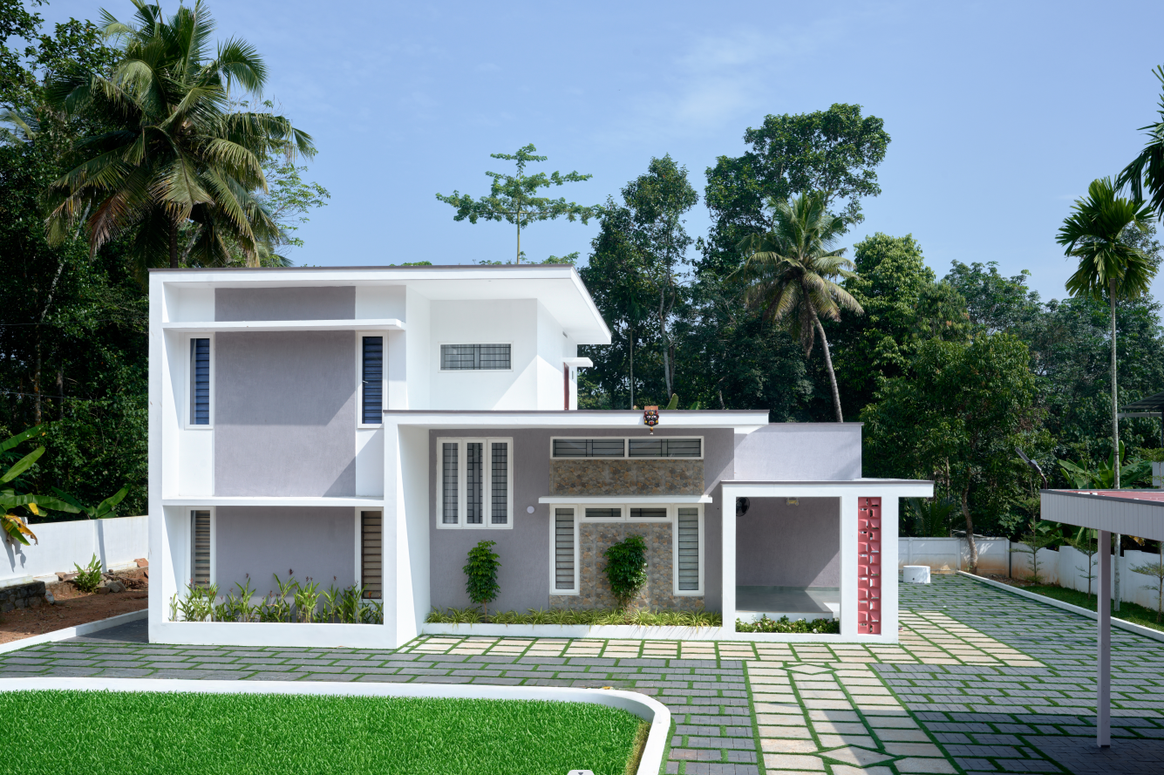
Design Intent and Concept
The homeowners envisioned a cozy, welcoming home that balanced modern aesthetics with the warmth of natural materials. BuildNext’s design team developed a contemporary layout anchored by a bright central courtyard, a feature that floods the interiors with natural light and gives the home an open, airy feel.
The living area, designed as the heart of the home, follows a wooden-toned theme that extends to the furniture, ceiling elements, and the striking staircase. The client specifically requested a wooden-finish interior, and BuildNext executed it with great care, ensuring the textures felt rich yet subtle. The clean lines, light walls, and warm wood tones together create a space that feels both elegant and comforting.
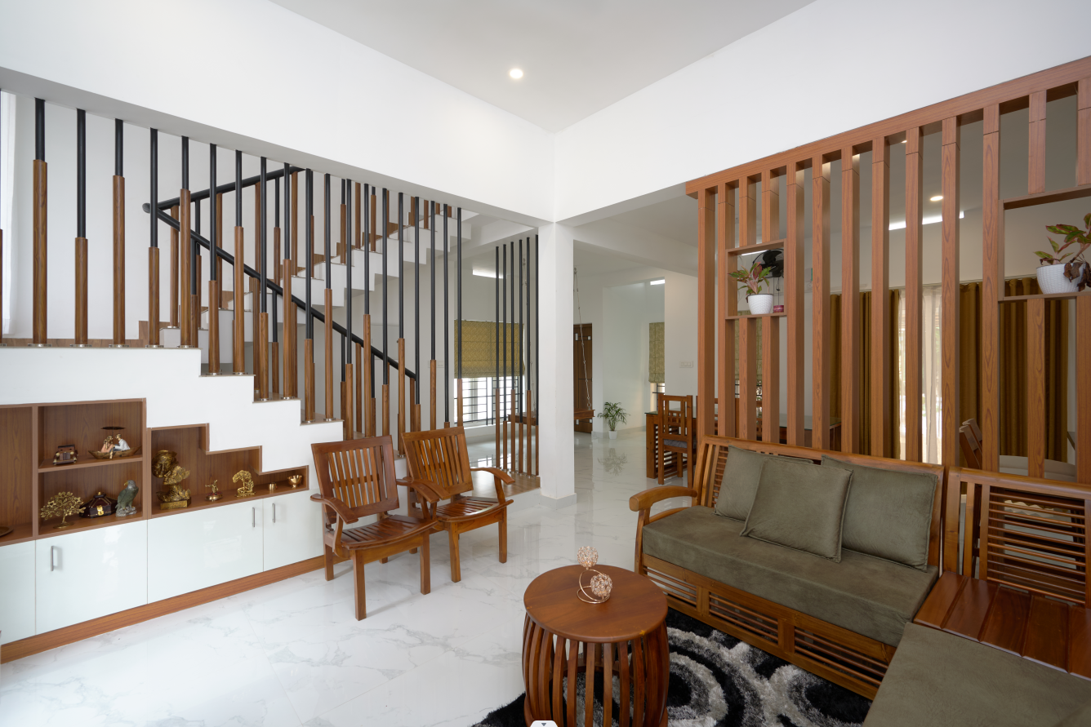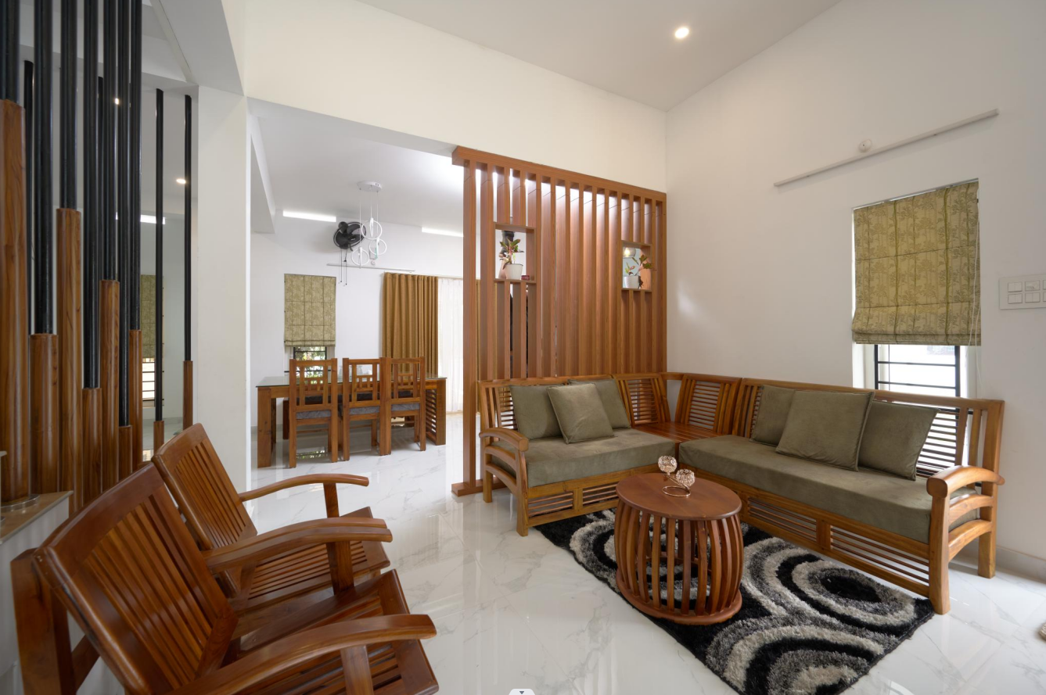

Planning Highlights
Although the living area space was compact, BuildNext’s design approach ensured it never felt confined. Smart spatial planning, ample ventilation, and the open connection with the courtyard made the interiors feel spacious and bright. The wooden staircase design became a standout element, admired by the clients for its sleek and minimal detailing.
Adding to the charm is a handcrafted wooden swing placed thoughtfully within the living space, a nostalgic touch that brings character and warmth to the modern design. The integration of the courtyard adjacent to the living area not only enhances the aesthetics but also improves cross-ventilation, creating a calm and refreshing ambience throughout the home.
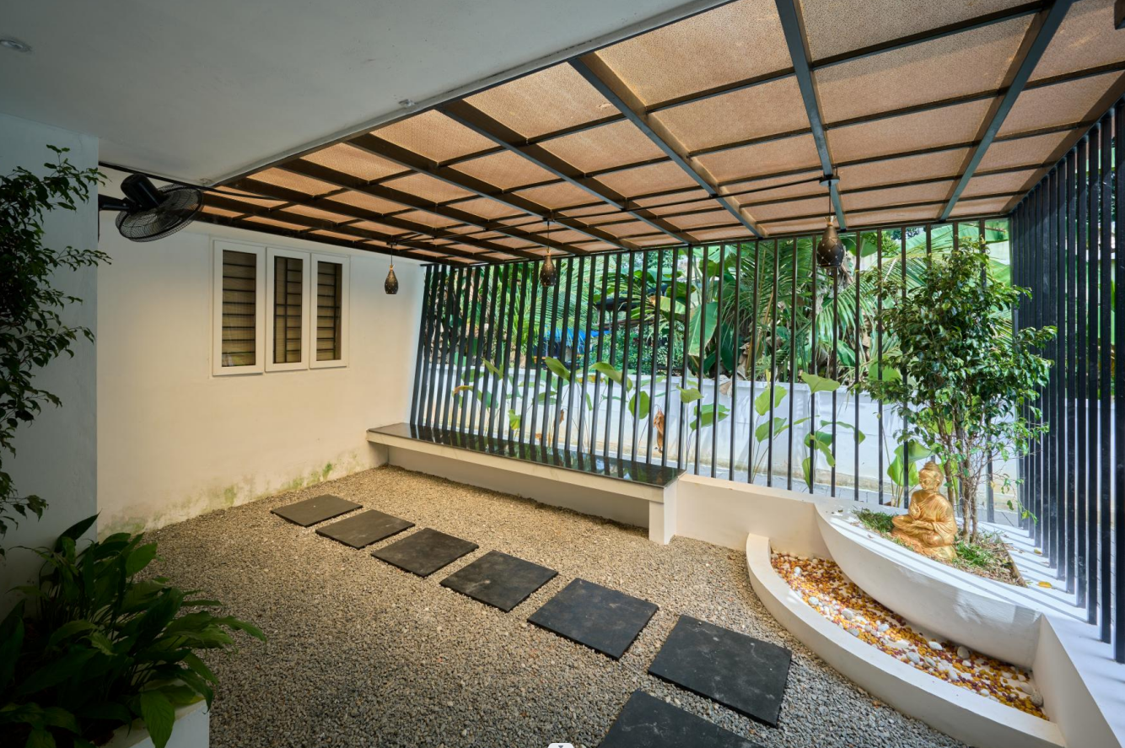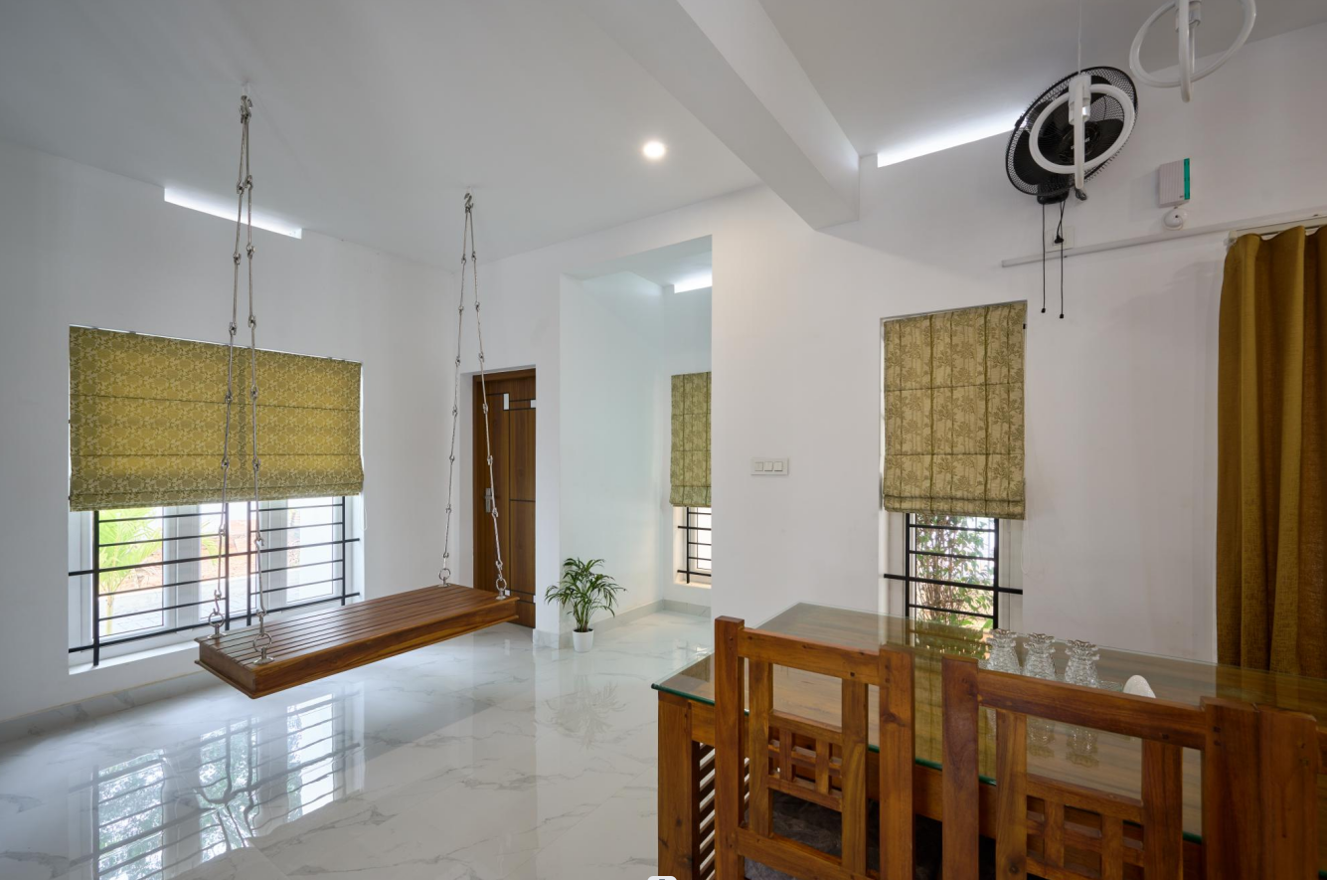
BuildNext Advantage
Before construction began, BuildNext’s Virtual Reality (VR) walkthrough allowed the clients to experience their home in full scale and detail, room by room, even before the first brick was laid. This immersive preview helped them visualize spatial relationships, fine-tune design elements, and make confident adjustments to layouts and finishes.
Once construction started, BuildNext’s Mobile App became their daily connection to the project. With progress updates, material tracking, and regular virtual meetings, the clients could stay fully informed and involved throughout the process — even while being away from the site. The combination of VR design previews and real-time digital project tracking ensured a smooth, transparent, and stress-free home-building experience.
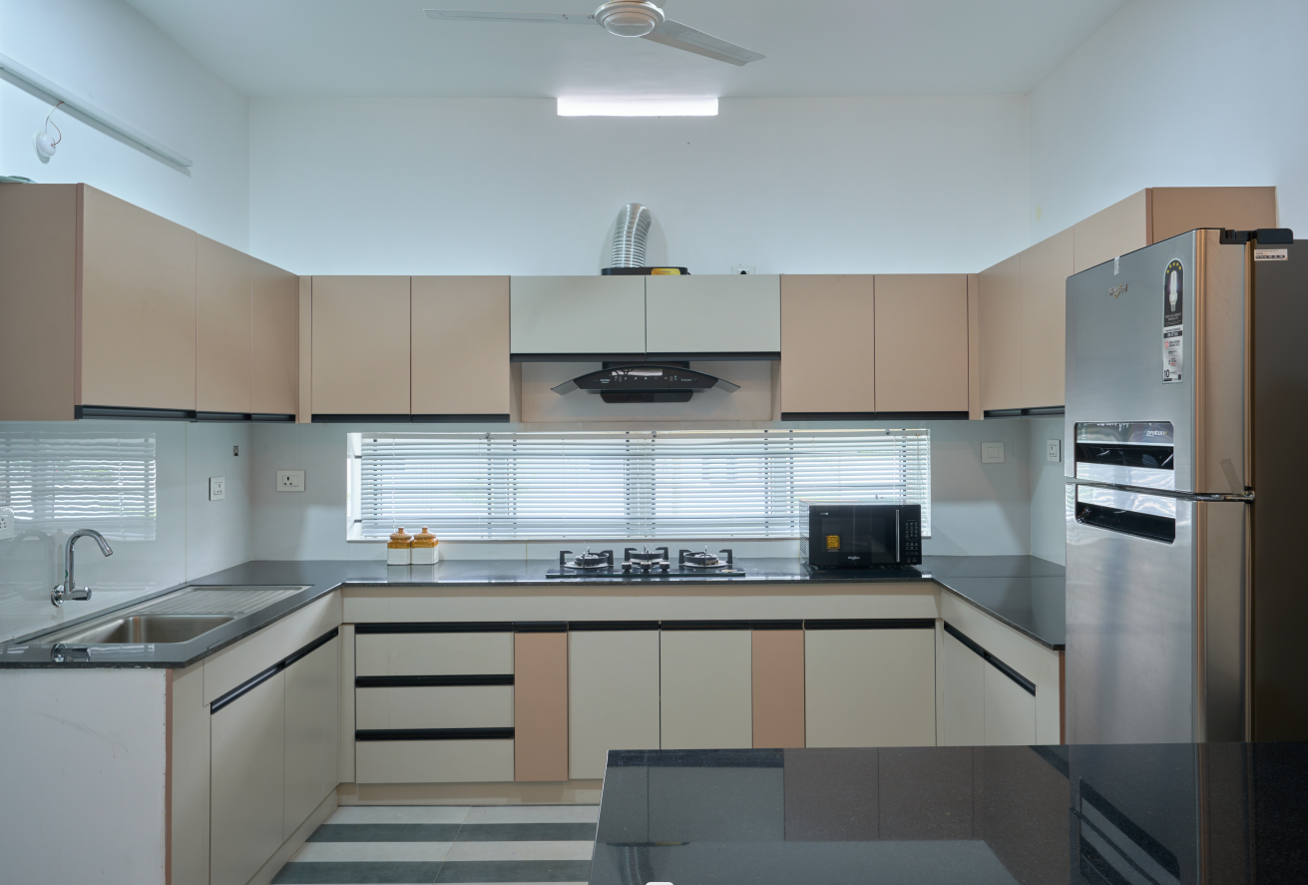
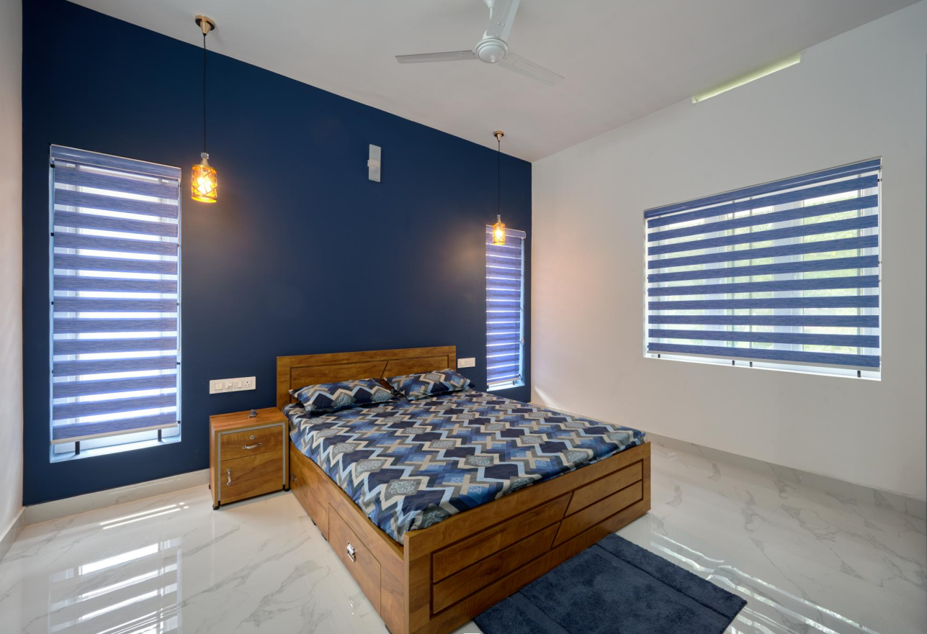

Outcome
The completed home in Kollam stands as a seamless blend of contemporary design and warm, earthy tones. The elegant wooden finishes, thoughtfully designed staircase, and inviting courtyard come together to create a residence that feels serene, functional, and timeless. Despite spatial constraints, the interiors feel open and alive — a testament to BuildNext’s expertise in maximizing comfort and style within modern homes.
